PowerTeacher Pro – Unified Classroom – Demographics
- Go to classroom.powerschool.com and enter in your login credentials. Please note: Your PowerSchool ID is your email address.
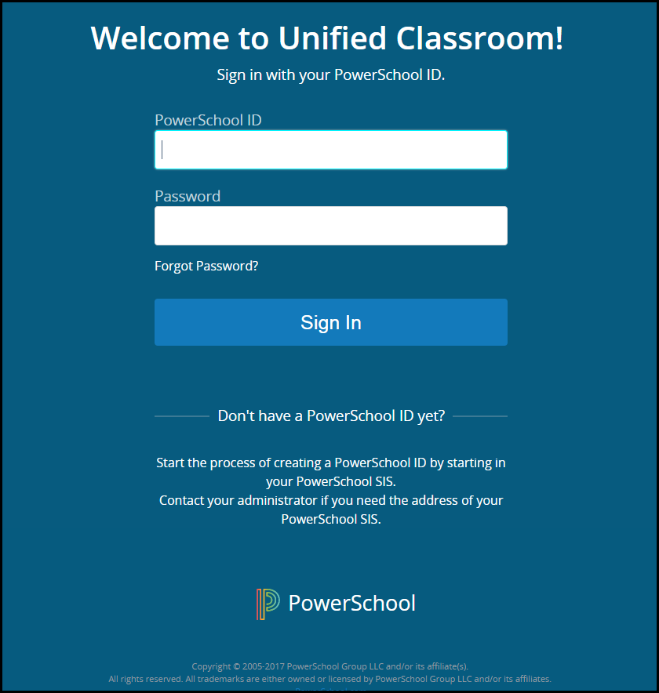
- Once you are logged in, click on “Quick Links”.
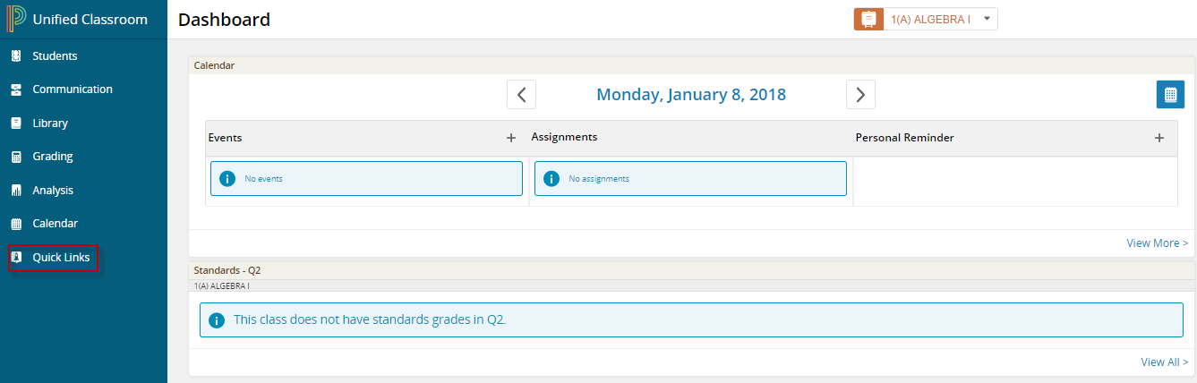
- Click on “PowerTeacher Portal Home”.
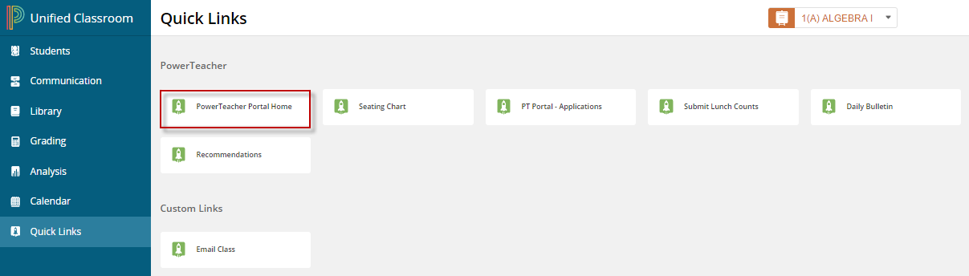
- Under Current Classes, navigate to your desired section and then click on the Backpack icon.
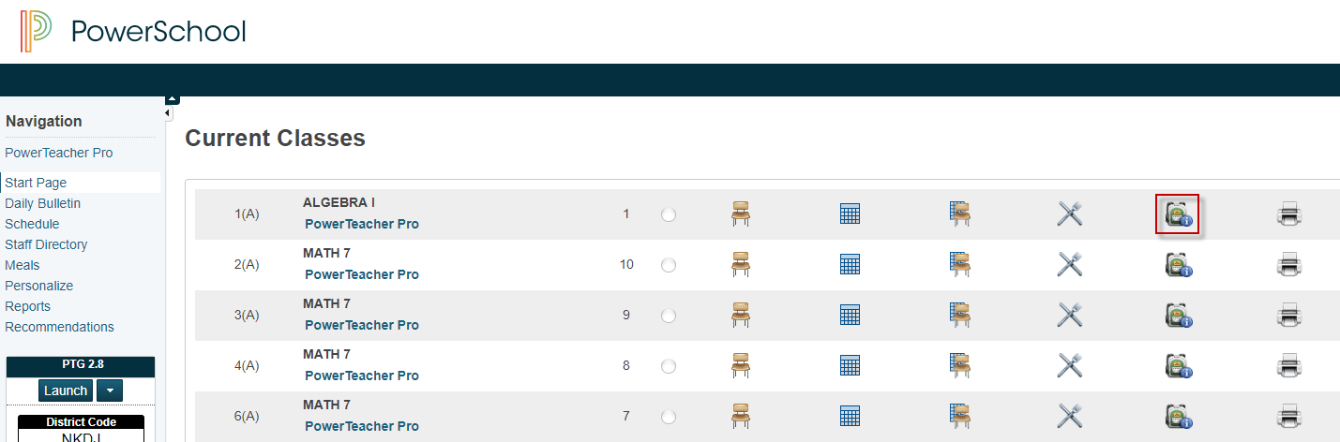
- Click on a student > Click on the dropdown arrow for “Select Screens” and select “Demographics.
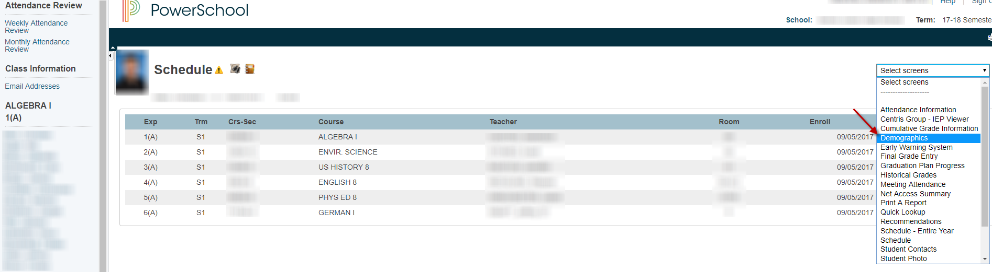
Please Note: When you click on a student’s last name, it will take you to the student’s schedule. If you click on the student’s first name, it will take you to the last screen you were on. In this case, you can continue to click on the student’s first name to view his or her demographic information.

